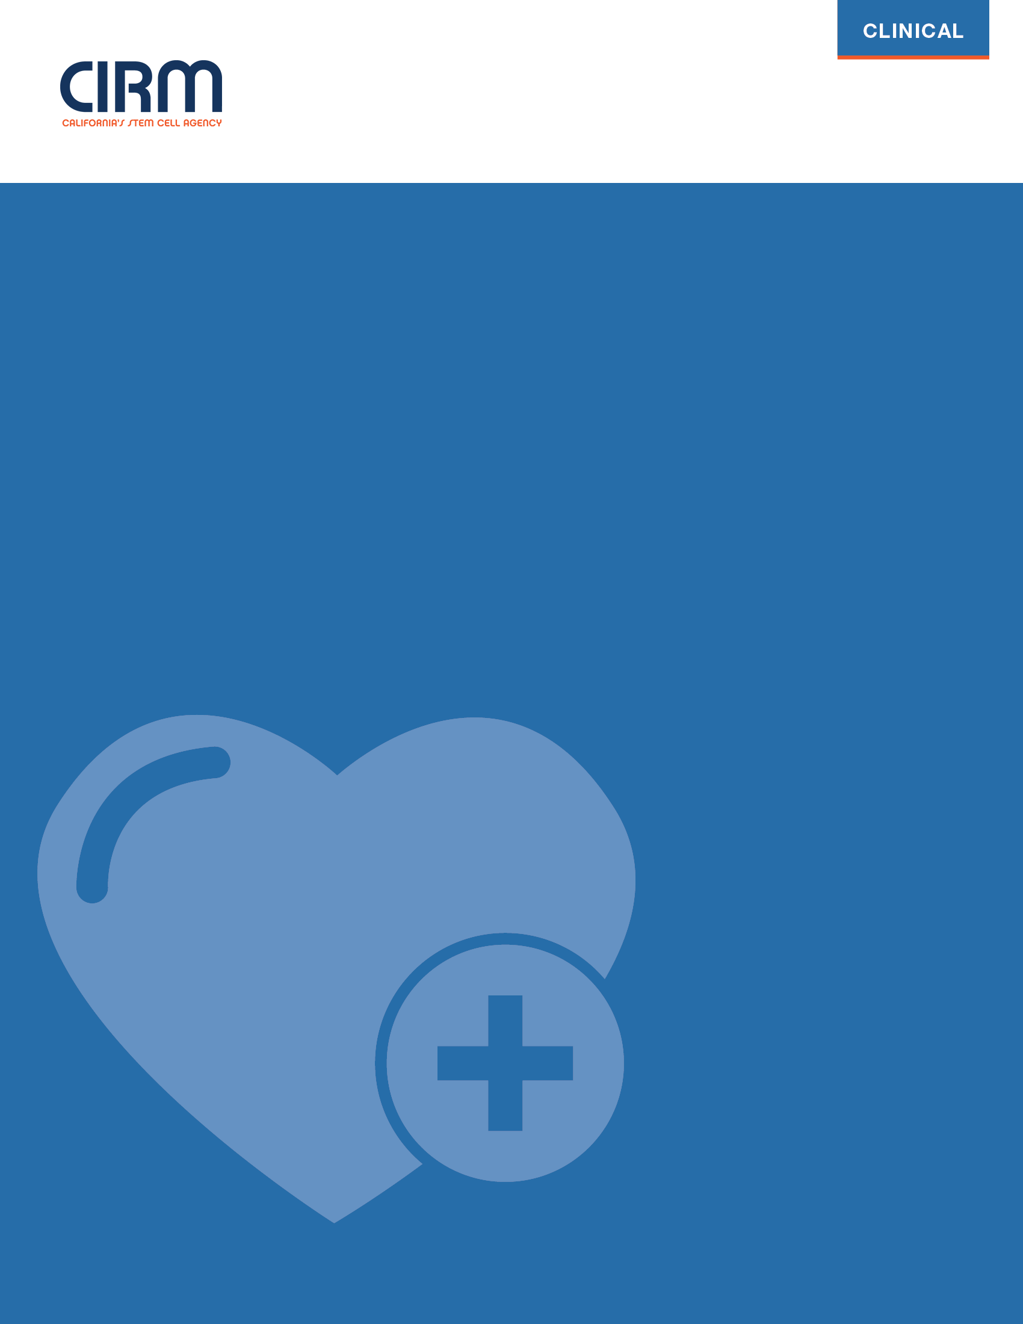

CIRM Funding Opportunity for Late Stage Development Projects

CLIN4

Proposal Template
March 12, 2024
CLIN4: Funding Opportunity for Late Stage Development Projects
This document is the proposal template for CLIN4 applicants. Please edit the footer text with your application number (i.e., replace ‘XXXXX’ with ‘12345’) and save your copy with a custom filename (i.e., CLIN4-12345 Proposal.docx).
The template includes full instructions, sample tables, tables to be populated by the applicant, and open sections for applicant responses. Applicants can add figures and tables to this document.
Applicants should not delete instructions. Do not modify the template font (Arial), font size (10 pt), margins (1” all around), table properties, or page orientations. No appendices are allowed.
Content that exceeds the template page or character limits will be deleted from the application.
When you have finished the proposal, fill in the page number for each proposal section in the Table of Contents, save as a PDF, and upload the document to your online application, along with requested documentation, on the ‘Document Uploads’ page.

Project Information
Application Number:
PI Name:
Email:
Project Title:

Contact
For inquiries about applying please contact clinical@cirm.ca.gov.
For inquiries about the review process please contact review@cirm.ca.gov.

Table of Contents
Proposal Section | Page
Resubmission Statement | <enter pg. #>
Project Summary | <enter pg. #>
Target Product Profile | <enter pg. #>
Value Proposition | <enter pg. #>
Diversity, Equity, & Inclusion (DEI) | <enter pg. #>
Scientific Rationale | <enter pg. #>
BLA Readiness Plan | <enter pg. #>
Gantt-like Timeline | <enter pg. #>
CLIN4 Project Plan | <enter pg. #>
Commercial Manufacturing Plan Synopsis | <enter pg. #>
Plans for Risk Mitigation & Financial Contingency | <enter pg. #>
Team Organization | <enter pg. #>
Resources & Project Environment | <enter pg. #>
Commercial Development Plan | <enter pg. #>
References | <enter pg. #>

Resubmission Statement
Are you resubmitting a substantially similar proposal that addresses Grants Working Group (GWG) reviewer comments on a previous CIRM application?
Yes.
No, this is a new application.

If “Yes” and your prior score was 3, please summarize your responses to the GWG reviewers and the changes you have made in the application.
If “Yes” and your prior score was 2, please provide a Revision Document, List of Changes, and redlined proposal per the instructions you received from CIRM. Contact review@cirm.ca.gov if you do not have these instructions. Leave this section blank.
Response length can be the rest of this page plus up to 1 additional page. Content exceeding the page limit will be deleted.

Project Summary
Provide a high-level summary of the proposed CLIN4 project, highlighting what you believe is most important for reviewers to consider.
Response length can be the rest of this page. Content exceeding this page will be deleted.

Updated Target Product Profile:
Populate the Target Product Profile (TPP) table below to provide base case and optimal product specifications for the drug product reflecting any new information obtained since submission of the parent CLIN2 application.
Base case: Minimally acceptable specifications that support attaining FDA approval, that differentiate the treatment from standard of care and other treatment options, and that provide a medically and commercially viable value proposition.
Optimal: Ideal specifications for the approved product that would meaningfully improve upon the base case profile.
FDA’s guidance document on TPPs may be a helpful resource. It is available from their website:
https://wayback.archive-it.org/7993/20190918100706/https://www.fda.gov/media/72566/download
Replace the <bracketed character limits> in the table below with your responses. Text exceeding the character limits will be deleted.

Target Product Profile (TPP)
Patient Population / Therapeutic Indication
Base case: Define the base case patient population. | Optimal: Define the optimal patient population.
<delete and enter text here> | <delete and enter text here>
Clinical Efficacy Endpoints
Base case: Define base case values for your proposed clinical efficacy endpoints. | Optimal: Define optimal values for your proposed clinical efficacy endpoints.
<Delete and enter text here. Define the clinical efficacy endpoints you will use for obtaining marketing approval, and base case values for these endpoints.> | <Delete and enter text here. Define the clinical efficacy endpoints you will use for obtaining marketing approval, and optimal values for these endpoints.>
Safety Risks
Base case: Describe the base case safety profile. | Optimal: Describe the optimal safety profile.
<delete and enter text here> | <delete and enter text here>
Contraindications
Base case: Describe the base case set of contraindications. | Optimal: Describe the optimal set of contraindications.
<delete and enter text here> | <delete and enter text here>
Dose & Regimen
Base case: Describe the base case dosing—include minimum, maximum and schedule. | Optimal: Describe the optimal dosing—include minimum, maximum and schedule.
<delete and enter text here> | <delete and enter text here>
Dosage Form & Route of Delivery
Base case: Describe base case dosage form and route of delivery. | Optimal: Describe optimal dosage form and route of delivery.
<delete and enter text here> | <delete and enter text here>

Value Proposition
Describe any new information or change relevant to the unmet need, therapeutic landscape, or standard of care since submission of the parent CLIN2 application. Discuss if there is any impact on the value proposition of the therapeutic candidate.
Avoid discussing the scientific rationale for the proposed product and/or completed investigational studies conducted with the proposed product or surrogate – these should be discussed in their respective sections, below.
Response length can be the rest of this page plus up to 1 additional page. Content exceeding the page limit will be deleted.

Diversity, Equity, & Inclusion (DEI)
CIRM’s Mission: Accelerating world class science to deliver transformative regenerative medicine treatments in an equitable manner to a diverse California and world.
To deliver on this mission, CIRM will ensure that development of CIRM funded therapeutics, where appropriate, include plans to be available to demographically diverse, underserved and disproportionately affected populations. Applicants are expected to address barriers faced by these populations to the candidate therapy. CIRM will track progress (and provide guidance and support) towards achieving these goals for all CLIN4 awardees to maximize the likelihood of success.
- Provide a statement describing how the research team has or will consider the influence of race, ethnicity, sex, gender, and age diversity in the development of the proposed therapy.
- Discuss the limitations, advantages and/or challenges of developing a product that addresses the unmet medical needs of the diverse California population, including underserved racial/ethnic communities.
- Address how the research team has or will incorporate diverse and inclusive perspectives and experience in the implementation of the project, including, for example, developing partnerships with patient organizations, acquiring training in cultural competence and/or DEI, utilizing institutional resources for DEI, and allocating funds and/or personnel to address DEI.
Response length can be up to 2 pages. Content exceeding the page limit will be deleted.

Scientific Rationale
Clinical:
- Provide a high-level narrative summary of the status of and available clinical data from the parent CLIN2 clinical trial and prior trials.
- In tabular form, provide detailed enrollment demographics and any available safety and efficacy data from the ongoing CLIN2 trial.
Regulatory:
- Summarize all regulatory interactions since the start of the CLIN2 award with emphasis on End-Of-Phase 2 or equivalent meeting(s) with FDA. Upload copies of all relevant FDA correspondence since the start of the CLIN2 award.
- Summarize specific issues and concerns discussed with FDA regarding potential BLA filing and agreements reached.
- Summarize your understanding of FDA expectations regarding what is needed for a BLA filing.
- Discussion of regulatory correspondence or other application uploads should reference the page number(s) where the applicable information can be viewed.
Response length can be the rest of this page plus up to 10 additional pages, including figures and excluding tables. Content exceeding the page limit will be deleted.

BLA Readiness Plan
Summarize all activities necessary to achieve readiness for a BLA filing. Include activities being conducted under the parent CLIN2 award and activities proposed under this CLIN4 award as well as any activities supported by other funding sources.
Response length can be the rest of this page plus up to 3 additional pages. Content exceeding the page limit will be deleted.

Gantt-Like Timeline
Provide a detailed timeline for all key activities necessary to achieve readiness for a BLA filing. Identify and/or highlight specific activities proposed for funding under this CLIN4 award.
The timeline should include all activities (CIRM-funded or not) necessary to achieve the CLIN4 Program Announcement objective (achieving readiness to apply for marketing approval and to initiate essential pre-commercialization activities) and should indicate any dependencies. It should also include the activities proposed in the DEI section of this proposal. Use a Gantt chart-like format.
Enter your timeline on this page and the next page, if needed. Content exceeding the page limit will be deleted.

CLIN4 Project Plan
Provide a detailed description of the activities proposed for funding under the CLIN4 award. Justify why they are necessary to achieve readiness for a BLA filing and how they will be implemented. Include a description of any proposed pre-commercialization activities.
Response length can be the rest of this page plus up to 6 additional pages. Content exceeding the page limit will be deleted.

Commercial Manufacturing Plan Synopsis
Summarize the plan to manufacture commercial-grade drug product using the table below. For each element in the table, summarize the current status and planned activities.
Table length can be the rest of this page plus up to 8 additional pages. Content exceeding the page limit will be deleted.

1. Clinical Manufacturing Experience
Provide Brief Description/Summary of:  - Table of clinical lots manufactured to date.  - What are the key manufacturing deviations/issues/risks identified to date? | CTD Section References:  3.2.S.4.4 Batch Analysis (for DS), and  3.2.P.3.4 Batch Analysis (for DP)
<delete and enter text here> | <delete and enter text here>
2. Manufacturing Readiness for Commercial Production
Provide Brief Description/Summary of:
- Has a Gap analysis been performed to identify gaps for Commercial manufacturing readiness?
- List the key gaps and your plans to address them.
- Which gaps will require substantial resources to close?
<delete and enter text here>
3. Cellular starting material
Provide Status of:  - Collection facility(ies) and how they will be qualified.  - Donor Selection & Qualification  - Collection Method  - Shipment to Manufacturing Facility  - Storage and Stability | CTD Section References:  3.2.S.2.3 Control of Materials, or  Separate DS Section
<delete and enter text here> | <delete and enter text here>
4a. Critical ancillary materials & Excipients: Animal or human source
Provide Status of:  - Manufacturer(s)/supplier(s) & qualification  - Testing and/or Quality Reference | CTD Section References:  3.2.S.2.3 Control of Materials  3.2.P.4 Control of Excipients
<delete and enter text here> | <delete and enter text here>
4b. Critical ancillary materials & Excipients: Non-animal/non-human source
Provide Status of:  - Manufacturer(s)/supplier(s) & qualification  - Testing and/or Quality Reference | CTD Section References:  3.2.S.2.3 Control of Materials  3.2.P.4 Control of Excipients
<delete and enter text here> | <delete and enter text here>
5. Viral/Non-viral Vector for genetic modification approaches (if applicable)
Provide Brief Status of:  - Manufacturing facility & quality system  - Manufacturing process  - Analytical assays  - Release Specifications | CTD Section References:  Separate DS Section
<delete and enter text here> | <delete and enter text here>
6. Device Component (if applicable)
Provide Brief Status of:  - Manufacturing facility(ies) & quality system(s)  - Device manufacturing  - Analytical Assays  - Release Specifications | CTD Section References:  Separate DS Section or as advised by FDA
<delete and enter text here> | <delete and enter text here>
7. Manufacturing Process for Drug Substance (DS) and Drug Product (DP)
Provide Brief Status of:  - Manufacturing facility(ies) & Quality System(s)  - Manufacturing Process  - Critical control points  Provide Brief Description/Summary of:  - Anticipated # of lots to be produced for Commercial.  - Does facility have the capacity to meet expected lot production figures?  - Are additional facilities needed for commercial production?  - Anticipated tech transfer challenges | CTD Section References:  3.2.S.2.2 Description of Manufacturing Process and Controls, and  3.2.P.3 Manufacture
<delete and enter text here> | <delete and enter text here>
8. Final Product Release Specifications for DP
Provide Brief Status of:  - Final product specifications  - Any anticipated refinement of DP specifications for phase 3 and/or commercial product | CTD Section References:  3.2.P.5.1 Specification
<delete and enter text here> | <delete and enter text here>
9. Analytical Assays for DP
Provide Status of Assay Development and Validation:  - Identity assay(s)  - Strength/Cell dose assay(s)  - Purity assay(s)  - Safety assays  - Potency assay(s)  Provide Brief Description/Summary of:  - Anticipated tech transfer challenges | CTD Section References:  3.2.P.5.2 Analytical Procedures, and  3.2.P.5.3 Validation of Analytical Procedures
<delete and enter text here> | <delete and enter text here>
10. Stability of DP
Provide Brief Status of:  - Stability-indicating assays  - Stability studies and plans | CTD Section References:  3.2.P.8 Stability
<delete and enter text here> | <delete and enter text here>
11. Labeling, Tracking, and Traceability
Provide Brief Status of:
Controls to ensure Chain of Identity and Custody
<delete and enter text here>
12. Instructions to Clinical Sites
Provide Brief Status of:  - Instructions for Product Storage at Clinical Site  - Instructions for On-Site Product Preparation  - Instructions for Product Administration | CTD Section References:  Will eventually be included in Module 1  1.14 Labeling  (Package Insert)
<delete and enter text here> | <delete and enter text here>
13. Common Technical Document, Module 3 Overall Preparation
Provide Brief Status of:  - Planning for BLA submission (e.g., file inventory, section drafts)  - Resources for regulatory writing and eCTD publishing | CTD Section References:  Module 3 Quality
<delete and enter text here> | <delete and enter text here>
14. Other Manufacturing Activities/Issues
Provide Brief Status of any other manufacturing activities/issues
<delete and enter text here>

Plans for Risk Mitigation & Financial Contingency
Discuss risks that could impact BLA Readiness.
Use the numbered format provided below. For each risk, do the following:
- Describe the project risk, including its potential impact on the project timeline.
- Detail plans for risk surveillance, mitigation, and contingency. (Risk surveillance and mitigation costs should be included in the project budget).
- Provide estimates of the contingency costs (e.g., the cost of an unplanned operational runs) and the investment of additional project time/operational cost required to implement the contingency plan.
- Identify a non-CIRM funding source to cover contingency costs. Provide a letter from the funder or your organization in your Letters of Support PDF upload, including acknowledgement and the dollar amount.
Use the format from these sample entries. At the end, sum the contingency costs into a total. This total must be included in the ‘Budget Justification > Financial Contingency Funds’ section of the online application.
Response length can be up to 2 pages. Content exceeding two pages will be deleted.

Risk #1:
Mitigation Strategy (1):
Contingency Costs (1):
Non-CIRM Source of Funding (1):

Risk #2:
Mitigation Strategy (2):
Contingency Costs (2):
Non-CIRM Source of Funding (2):

Risk #3:
Mitigation Strategy (3):
Contingency Costs (3):
Non-CIRM Source of Funding (3):

Total Contingency Costs for the Project (sum of the costs above):

Team Organization
Summarize the qualifications of the proposed team and plans for team collaboration. Summarize plans for division of tasks, communication, and shared decision making among the Key Personnel (including consultants or contractors who are Key Personnel).
Response length can be up to one page. Content exceeding one page will be deleted.

Resources & Project Environment
Provide a brief description of the facilities, environment(s), core services, and resources available for conducting the proposed project. Include brief descriptions of resources for DEI-related efforts.
Response length can be the rest of this page plus up to 1 additional page. Content exceeding the page limit will be deleted.

Commercial Development
Describe your plan for commercialization of the proposed product. Plans can include pharmacoeconomic analysis, budget impact models, Payors Cost-Effectiveness Analysis, compilation of an Academy of Managed Care Pharmacy (AMCP) Dossier, development of a supply chain strategy.
Response length can be the rest of this page plus up to 3 additional pages. Content exceeding the page limit will be deleted.

References
List all references used in the body of the proposal.

